|  |  |
| --- | --- |
| Date of investigation | 3-11-2020 9:06 pm est |
| Date of incident | 2012-07-18 |
| Outcome | A heist was planned on the national gallery |
| Action Taken | Phone was confiscated and investigated |
| Reporting Tool | Autopsy, DB Browser for SQLite |
| Attack Vector (Web, Email, Network, etc…) | Physical thief |

Narrative

* Started investigations into the national gallery heist
* 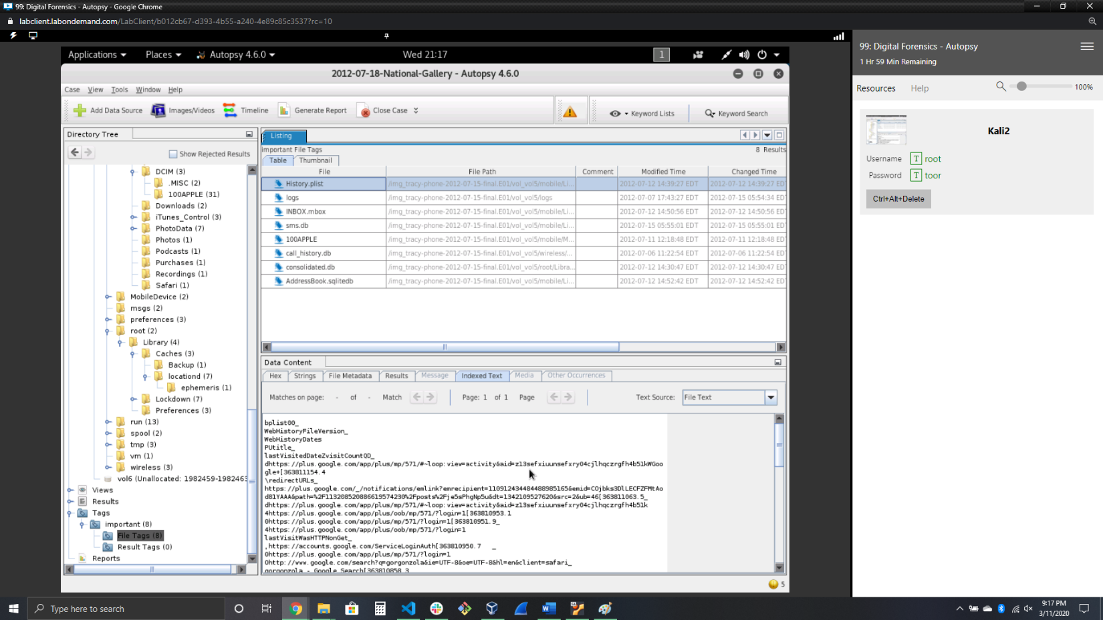Looking at Tracy’s web history I can see what type of searches were done
* Looking at the email I can see where the motivation came from and the plans

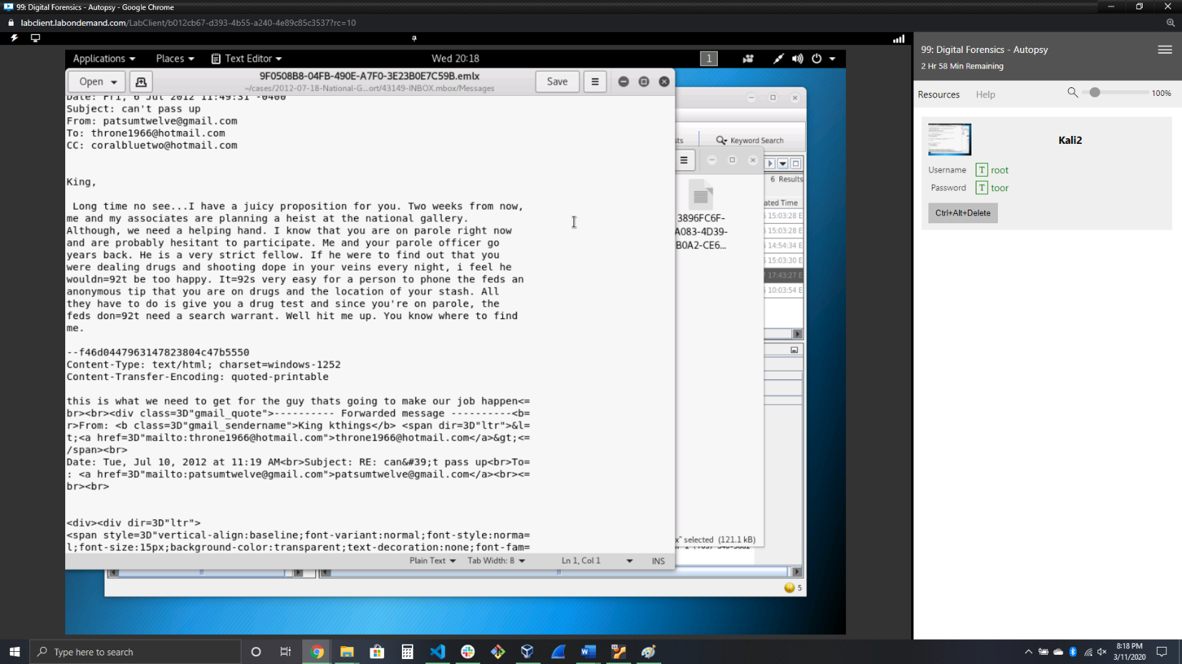

* Looking at the texts I found figured out who was who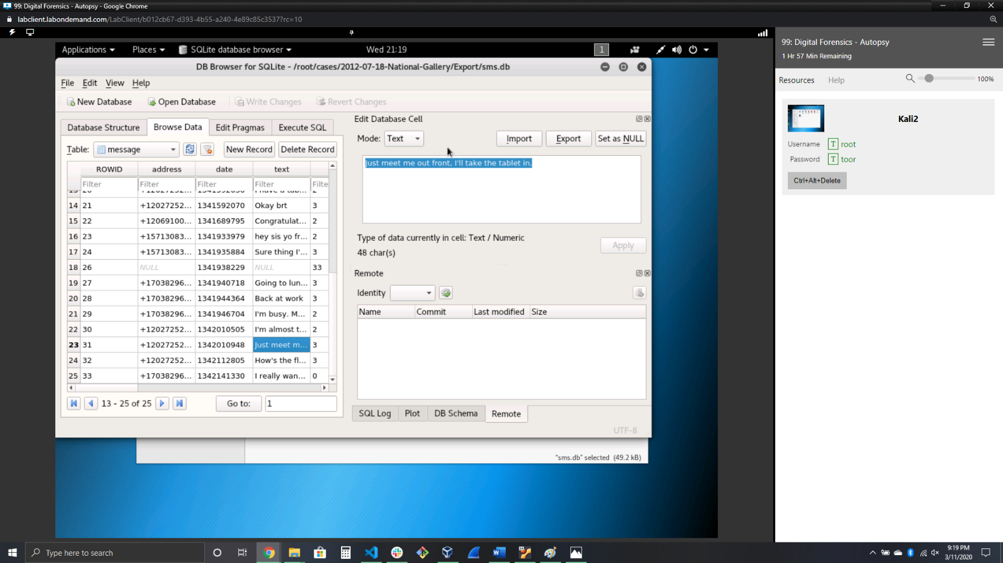
* 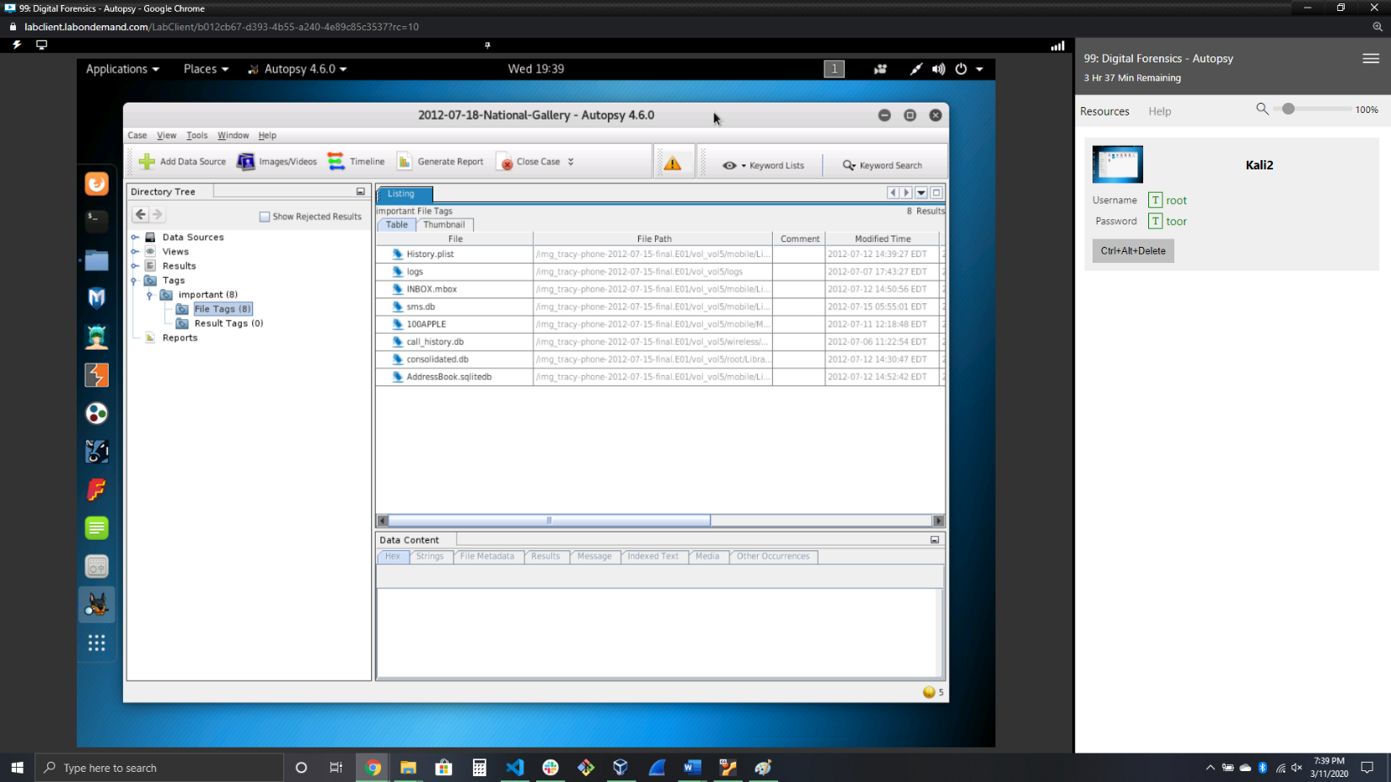Put all of my findings into one location to make it easier to reference info later
* 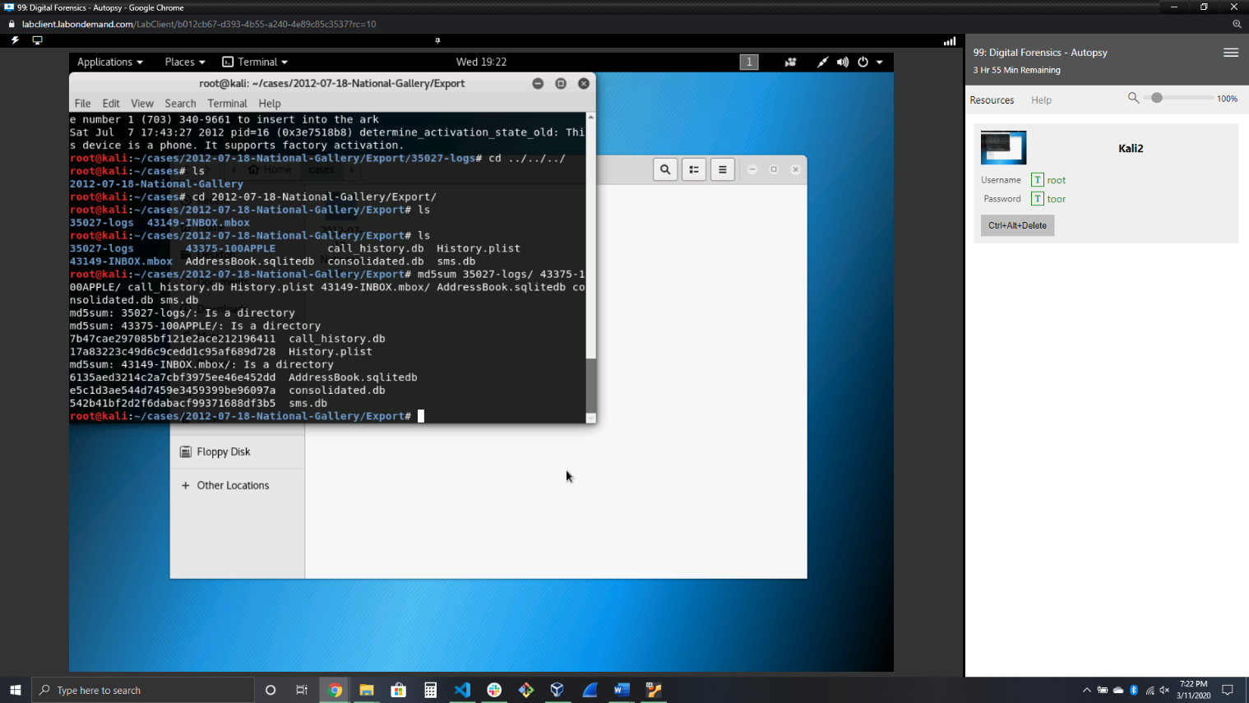Hashed the files to verify their validity